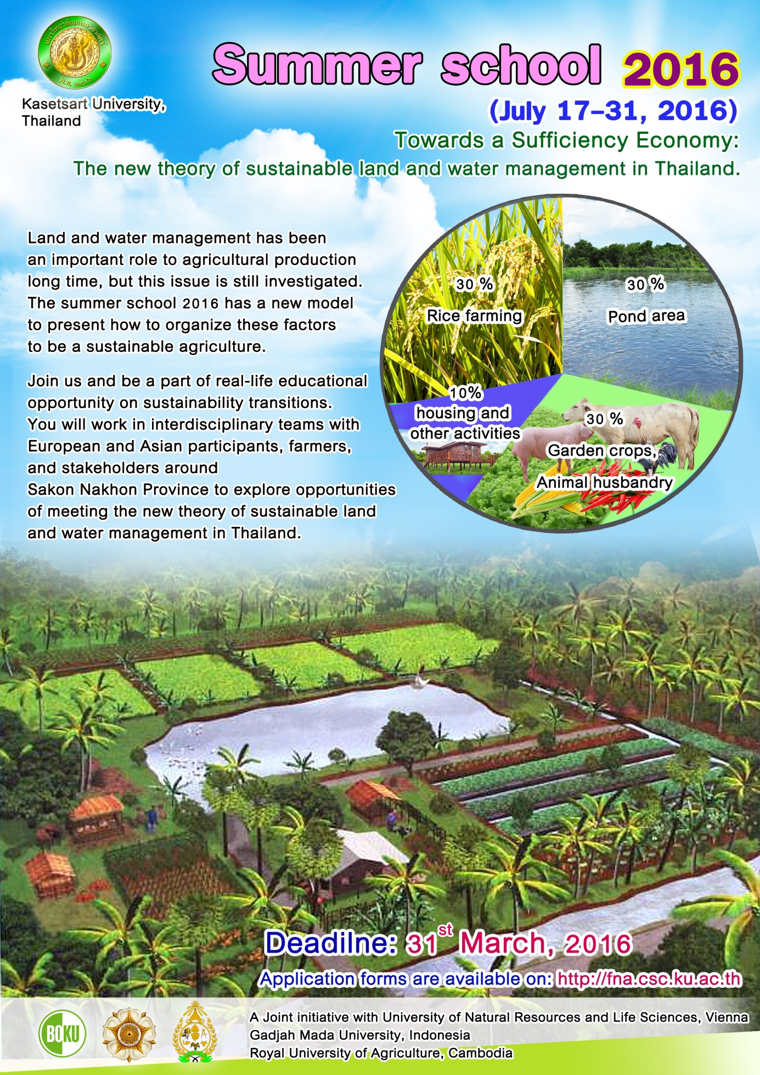

Application form

- Please fill this form electronically, use ‘app_STSS2016_last name_first name’ as file name and submit it in PDF-format.
- Please submit to the respective contact person at your university:
BOKU: Lorenz Probst, Centre for Development Research (lorenz.probst@boku.ac.at)
UGM: Francis Setyabudi, Department of Food and Agricultural Product Technology (francis.setyabudi@gmail.com)
KU: Hathairat Chokthaweepanich, Faculty of Natural Resources and Agro-Industry (hathairat.ch@ku.th)
RUA: Lyda Hok
- Deadline of submission: 31st March 2016

Section 1: PERSONAL DETAILS

Family name/Last name:
(This is the name under which your file will be registered)

Given name/First name:

Title: | Male:  Female: | Date of birth: | Nationality:

Address:

E-Mail address: | Telephone number (mobile):  (With international code)

Fax number:  (With international code) | Telephone number (work/home):  (With international code)

Section 2: ACADEMIC INFORMATION AND EXPERIENCE

University/Faculty:

Degree (e.g. BSc) and course programme(s):

Year of study (for all applicants) / student number (for BOKU applicants)

Which courses related to transitions towards sustainable management of natural resources have you attended?

Which other relevant courses have you attended?

English skills

BOKU / UGM / RUA applicants only: Do you have work experience in Thailand?
No:

Yes
If yes: Place:

Duration:

Activity:

Section 3: QUESTIONS ON GOALS, RESOURCES, AND NEXT STEPS

Please answer the following questions. Use font Calibri, size 12, single-line, maximum 100 words per answer.

What professional goals do you pursue in connection with transitions towards sustainable management of natural resources?

How will your attendance at the Sustainability Transitions Summer School 2015 help you to realize your anticipated goals?

Which resources (skills, knowledge, information, experiences, financial, etc.) do you already have to successfully attend the Summer School?

Which resources (skills, knowledge, information, experiences, financial, etc.) do you still need to successfully attend the Summer School?

How will you gain the necessary resources (skills, knowledge, information, experiences, financial, etc.) to successfully attend the Summer School?

What assistance do you expect from your peers (i.e. participants from BOKU, UGM, RUA, and KU) during this Summer School?

How will you assist your peers (i.e. participants from BOKU, UGM, RUA, and KU) and the supervisors and trainers during this Summer School?

What are your next preparatory steps and activities to successfully attend the Sustainability Transitions Summer School 2015?

Section 4: MOTIVATION LETTER

The motivation letter provides the opportunity to express interests and reasons that are not covered by the questions asked in Section 3. Please write the motivation letter using font Calibri, size 12, single-line, maximum 400 words.

Motivation letter:

